PL SQL Hands-On Solutions

Exercise-1: Control Structures

1.Create Customer and Loans Tables and insert sample values in it

CREATE TABLE Customers (
CustomerID NUMBER PRIMARY KEY,
CustomerName VARCHAR2(50),
Age NUMBER,
Balance NUMBER(10,2),
IsVIP VARCHAR2(5)
);

CREATE TABLE Loans (
LoanID NUMBER PRIMARY KEY,
CustomerID NUMBER,
InterestRate NUMBER(5,2),
DueDate DATE,
CONSTRAINT fk_customer
FOREIGN KEY(CustomerID)
REFERENCES Customers(CustomerID)
);

INSERT INTO Customers VALUES (101,'Rahul',65,15000,'FALSE');
INSERT INTO Customers VALUES (102,'Priya',45,9000,'FALSE');
INSERT INTO Customers VALUES (103,'Amit',70,25000,'FALSE');
INSERT INTO Customers VALUES (104,'Neha',35,12000,'FALSE');
INSERT INTO Loans VALUES (1,101,9.50,SYSDATE+15);
INSERT INTO Loans VALUES (2,102,8.00,SYSDATE+60);
INSERT INTO Loans VALUES (3,103,10.00,SYSDATE+20);
INSERT INTO Loans VALUES (4,104,7.50,SYSDATE+10);
COMMIT;

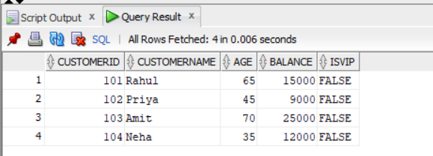

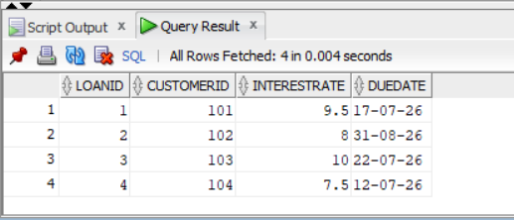

Scenario 1 Solution:-

BEGIN
FOR c IN (
SELECT CustomerID
FROM Customers
WHERE Age > 60
)
LOOP
UPDATE Loans
SET InterestRate = InterestRate - 1
WHERE CustomerID = c.CustomerID;
END LOOP;

COMMIT;

DBMS_OUTPUT.PUT_LINE('Interest rate discount applied successfully.');
END;
/

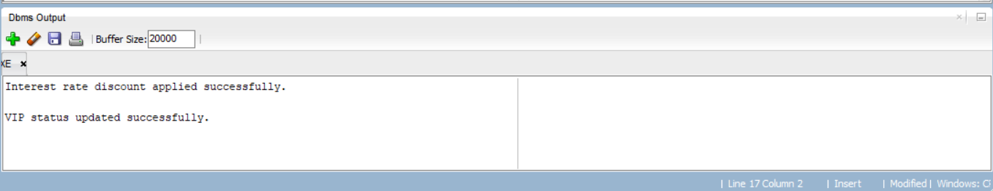

Updated table after running the query:



Scenario - 2 Solution:-

BEGIN
FOR c IN (
SELECT CustomerID
FROM Customers
WHERE Balance > 10000
)
LOOP
UPDATE Customers
SET IsVIP='TRUE'
WHERE CustomerID=c.CustomerID;
END LOOP;

COMMIT;

DBMS_OUTPUT.PUT_LINE('VIP status updated successfully.');
END;
/



Updated query after running query:

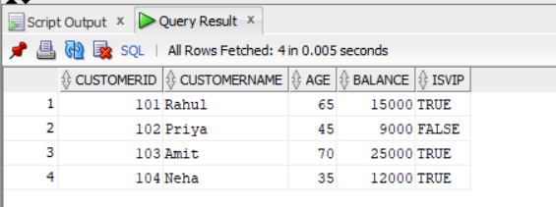

Scenario 3 Solution :-

BEGIN
FOR r IN (
SELECT c.CustomerName,
l.DueDate
FROM Customers c
JOIN Loans l
ON c.CustomerID=l.CustomerID
WHERE l.DueDate BETWEEN SYSDATE AND SYSDATE+30
)
LOOP
DBMS_OUTPUT.PUT_LINE(
'Reminder: '
|| r.CustomerName
|| ' has a loan due on '
|| TO_CHAR(r.DueDate,'DD-MON-YYYY')
);
END LOOP;
END;
/

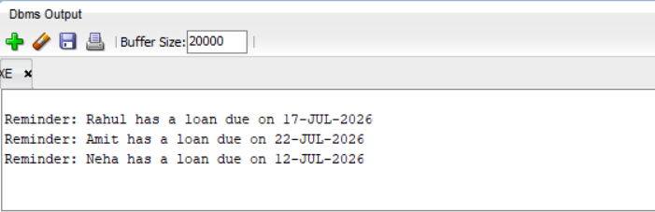

Exercise-3: Stored Procedures

Scenario 1 Solution:-
1.Create Customer and Loans Tables and insert sample values in it

CREATE TABLE Accounts(
AccountID NUMBER PRIMARY KEY,
CustomerName VARCHAR2(50),
AccountType VARCHAR2(20),
Balance NUMBER(10,2)
);

CREATE TABLE Employees(
EmployeeID NUMBER PRIMARY KEY,
EmployeeName VARCHAR2(50),
Department VARCHAR2(30),
Salary NUMBER(10,2)
);

INSERT INTO Accounts VALUES(101,'Rahul','Savings',20000);
INSERT INTO Accounts VALUES(102,'Priya','Savings',15000);
INSERT INTO Accounts VALUES(103,'Amit','Current',30000);
INSERT INTO Accounts VALUES(104,'Neha','Savings',12000);
INSERT INTO Employees VALUES(1,'Raj','IT',50000);
INSERT INTO Employees VALUES(2,'Aman','HR',40000);
INSERT INTO Employees VALUES(3,'Kiran','IT',60000);
INSERT INTO Employees VALUES(4,'Riya','Finance',45000);
COMMIT;

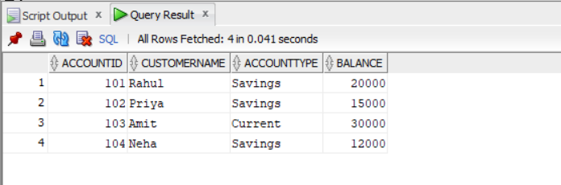

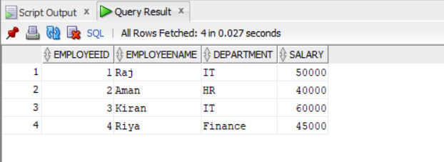

Scenario 1 Solution:-

CREATE OR REPLACE PROCEDURE ProcessMonthlyInterest
AS
BEGIN
UPDATE Accounts
SET Balance = Balance + (Balance * 0.01)
WHERE AccountType='Savings';

COMMIT;

DBMS_OUTPUT.PUT_LINE('Monthly interest processed successfully.');
END;
/

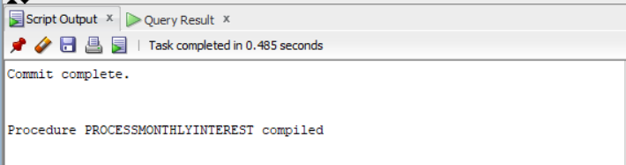

Updated table after running the query:

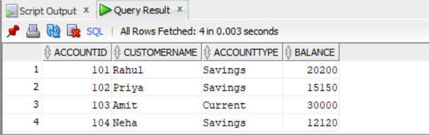

Scenario 2 Solution:-

CREATE OR REPLACE PROCEDURE UpdateEmployeeBonus(
p_department IN VARCHAR2,
p_bonus IN NUMBER
)
AS
BEGIN
UPDATE Employees
SET Salary = Salary + (Salary * p_bonus /100)
WHERE Department=p_department;

COMMIT;

DBMS_OUTPUT.PUT_LINE('Employee bonus updated successfully.');
END;
/

2.Give 10% bonus to IT department.
BEGIN
UpdateEmployeeBonus('IT',10);
END;
/

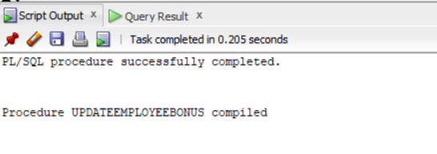
Updated table after running this query:

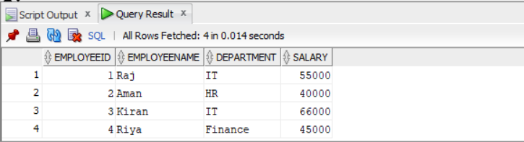

Scenario 3 Solution:-

CREATE OR REPLACE PROCEDURE TransferFunds(
p_from IN NUMBER,
p_to IN NUMBER,
p_amount IN NUMBER
)
AS
v_balance NUMBER;
BEGIN

SELECT Balance
INTO v_balance
FROM Accounts
WHERE AccountID=p_from;

IF v_balance>=p_amount THEN

UPDATE Accounts
SET Balance=Balance-p_amount
WHERE AccountID=p_from;

UPDATE Accounts
SET Balance=Balance+p_amount
WHERE AccountID=p_to;

COMMIT;

DBMS_OUTPUT.PUT_LINE('Fund transfer successful.');

ELSE
DBMS_OUTPUT.PUT_LINE('Insufficient Balance.');
END IF;
END;
/

Execute Procedure
Transfer 5000 from Account 101 to Account 102
BEGIN
TransferFunds(101,102,5000);
END;
/

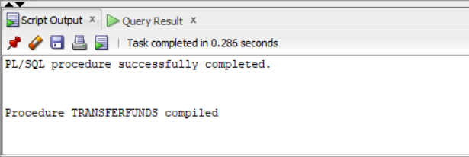

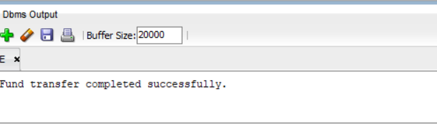

Updated table after running the query:

